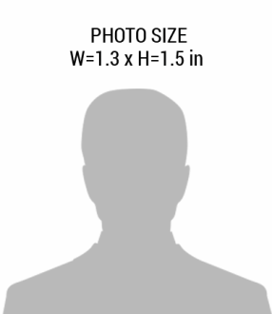pic.png

**EXP.**

07-04-2026

09112001

**ID #:**

Eric Hagg

**Security Professional**

Logo Security